
Hkkjrh; izkS|ksfxdh LkaLFkku iVuk
Indian Institute of Technology Patna
Department of Electrical Engineering
IIT Patna, Campus, Bihta, Patna, Bihar – 801103 Experiment: 5

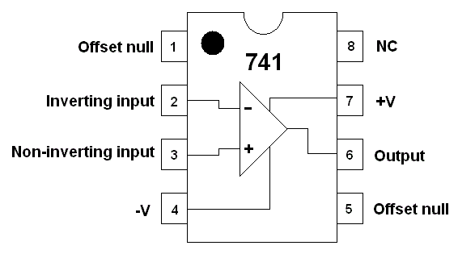
OPERATIONAL AMPLIFIER - I

OBJECTIVE : Realization of amplifier circuits with Op-Amp (Operational Amplifier).

COMPONENTS REQUIRED

- Components
Op-Amp : One: LM741.
Resistance : Five: 1 kΩ (1 no), 10 kΩ (1 no), 12 kΩ (2 nos),
100 kΩ (1 no).

PRECAUTIONS AND GUIDELINES

1. The op-amp generally works on split power supply (e.g. ±12 V). Both positive and negative power supplies must be present whenever op-amp is powered. The range of power supply is from ±5 V to ±15 V. Do not forget to connect the common terminal of the power supply to the ground on the breadboard.

2. Connecting only one side of power supply or interchanging positive and negative power supplies damages the op-amp.

3. For connecting power supply, you have to follow the procedure as given below.
a. Disconnect the power supply to op-amps.
b. Switch on the power supply.
c. Set the output voltage as required (e.g. ±12 V).
d. Switch off the power supply.
e. Connect the power supply to op-amps.
f. Switch on the power supply.

4. For any IC, never exceed the input voltage beyond the power supply limits.
5. Use the horizontal strips of the breadboard for power supply. Tap the power supply for each IC from these supply lines.
6. Keep ground terminals of the oscilloscope, probes and function generator output, and power supply common connected together throughout the experiment.
7. Use AFG in “High Z” mode.

Pre-experiment Reading:
Obtain the theoretical values of Vo / Vi for step 5 of Part A. Do this for Part B also.

PART A : INVERTING AMPLIFIER

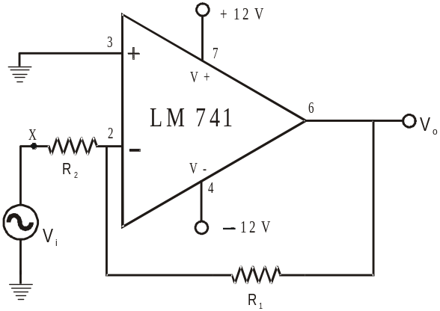

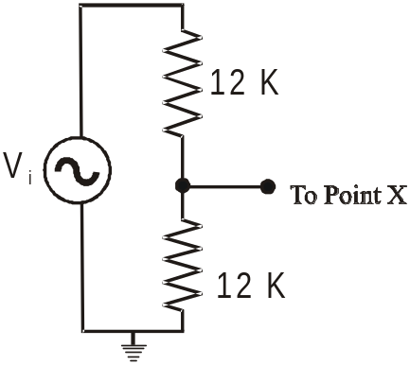

Fig. 5.1 Inverting Amplifier Fig 5.2 Voltage Divider

1. Assemble the circuit shown in Fig. 5.1 with R1 = 10 kΩ and R2 = 1 kΩ. Make sure the power supply ground is connected to the circuit ground.

2. Apply 200 mVp-p, 1 kHz sine wave at Vi from the function generator and see the output.

3. Observe Vo and Vi, and determine voltage gain A = Vo / Vi. Also obtain A for Vi = 100 mVp-p and 300 mVp-p.

4. Change R1 & R2 to 100 kΩ & 10 kΩ respectively and determine A for Vi = 100 mVp-p, 200 mVp-p and 300 mVp-p.
5. Now apply a fraction of the voltage Vi (keeping Vi at 200 mVp-p) to the point ‘X’ through the potential divider circuit (instead of directly connecting the source at ‘X’) as shown in Fig. 5.2 and note the values of Vo for

(i) 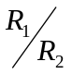= 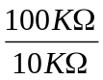 and (ii) = 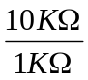

Compute Vo / Vi for (i) and (ii).

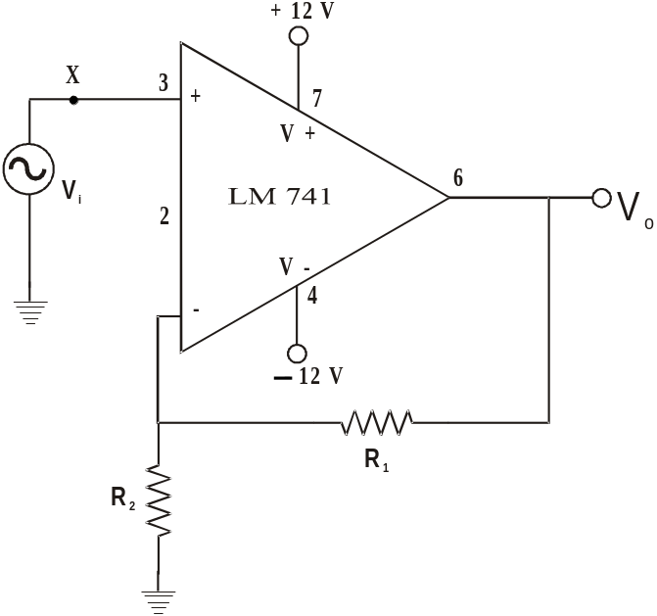PART B : NON-INVERTING AMPLIFIER

1) Assemble the circuit shown in Fig. 5.3 with R1 = 10 kΩ and
R2 = 1 kΩ. Make sure the power supply ground is
connected to the circuit ground.

2) Apply 200 mVp-p, 1 kHz sine wave at Vi from the function
generator and see the output.
3) Observe Vo and Vi, and determine voltage gain A = Vo / Vi.
Also obtain A for Vi = 100 mVp-p and 300 mVp-p.

4) Change R1 & R2 to 100 kΩ & 10 kΩ respectively and determine
A for Vi = 100 mVp-p, 200 mVp-p and 300 mVp-p.
5) Now apply a fraction of the voltage Vi (keeping Vi at 200
mVp-p) to the point ‘X’ through the potential divider circuit
as shown in Fig. 5.2 and note the values of Vo for

Fig. 5.3 Non-inverting amplifier
(i) = and

(ii) =

Compute Vo / Vi for (i) and (ii).

Q1. For a source with high internal impedance which configuration (inverting or non-inverting) will be suitable for designing a good amplifier?

Q2. Design an Amplifier system to obtain a gain of ‘-50’ for a source with high internal resistance. You may use combinations of inverting and non-inverting configurations. (Make use of answer of Q1.)

